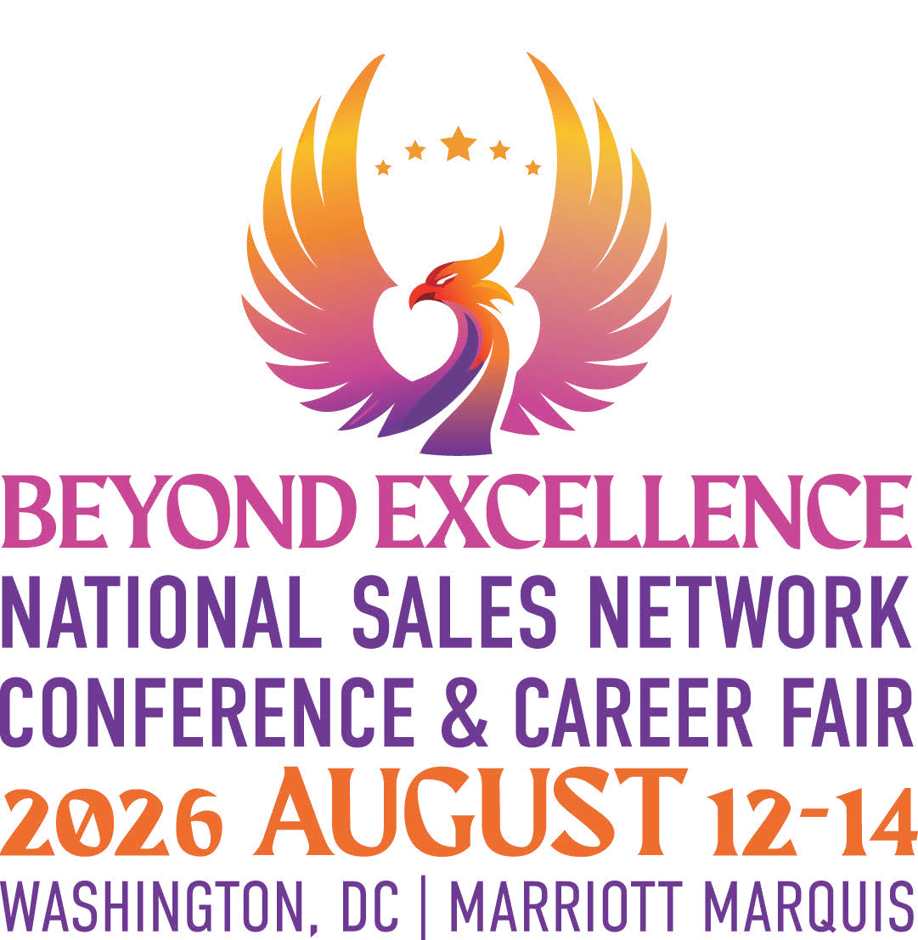

To: [Vice President of Human Resources / Your Direct Manager or appropriate title]
Subject: National Sales Network’s 29th Annual Conference

National Sales Network will convene for its 29th Annual Conference on August 12-14, 2026. Over 2,500 professionals from various industries are expected to participate in three days of workshops and executive level presentations geared toward enhancing sales skills, improving sales leadership effectiveness, and learning leading edge sales strategies and tactics. The theme of this year’s conference is “Beyond Excellence.” The conference will focus on “Sales Excellence.”
Corporations like ours are increasingly becoming aware of the value that NSN offers to its participants. NSN conference attendees can discover what it takes to be successful in a changing marketplace and acquire tangible skills that go beyond what is offered by company driven internal sales & sales management training programs. NSN Conference attendees interact with executive-level professionals and are inspired by nationally renowned speakers. They take part in interactive tracks (see below) that fine-tune skills, enhance professional development, build working relationships, and increase business acumen.
Track Number of Workshops / Sessions
Sales Professionals 5
Future Sales Managers 2
Sales Managers 4
Master Classes 4
Women’s Only Career Strategy Sessions 4
Using AI To Increase Sales Effectiveness 2
VP of Sales Panels (general session) 2
Career Strategies 2
Featured Speakers (general session) 8

Established in 1992, National Sales Network is a 501(c)(3) non-profit organization open to everyone whose mission is to meet the professional and developmental needs of sales and sales management professionals. The purpose of the organization is to increase career growth and skill development as well as provide a forum for networking within the sales profession. Please visit their website at www.salesnetwork.org for additional information.
I am requesting your approval to cover the cost to attend the NSN Conference this year as a part of my professional development / individual development plan. I hope you will consider sponsoring my participation.
Sincerely,
(Your name)

