To: Vice President of Human Resources / Your Direct Manager (or appropriate title)
From: (Your name)
Subject: National Sales Network’s 26th^{t} Annual Conference
August 2 – 4, 2023 | Dallas, Texas

National Sales Network will convene for its 26st Annual Conference on August 2 – 4, 2023. Over 2,000 professionals from various industries are expected to participate in three days of workshops and executive level presentations geared toward enhancing sales skills, improving sales leadership effectiveness and learning leading edge sales strategies and tactics. The theme of this year’s conference is “The New Corporate Intrapreneur”
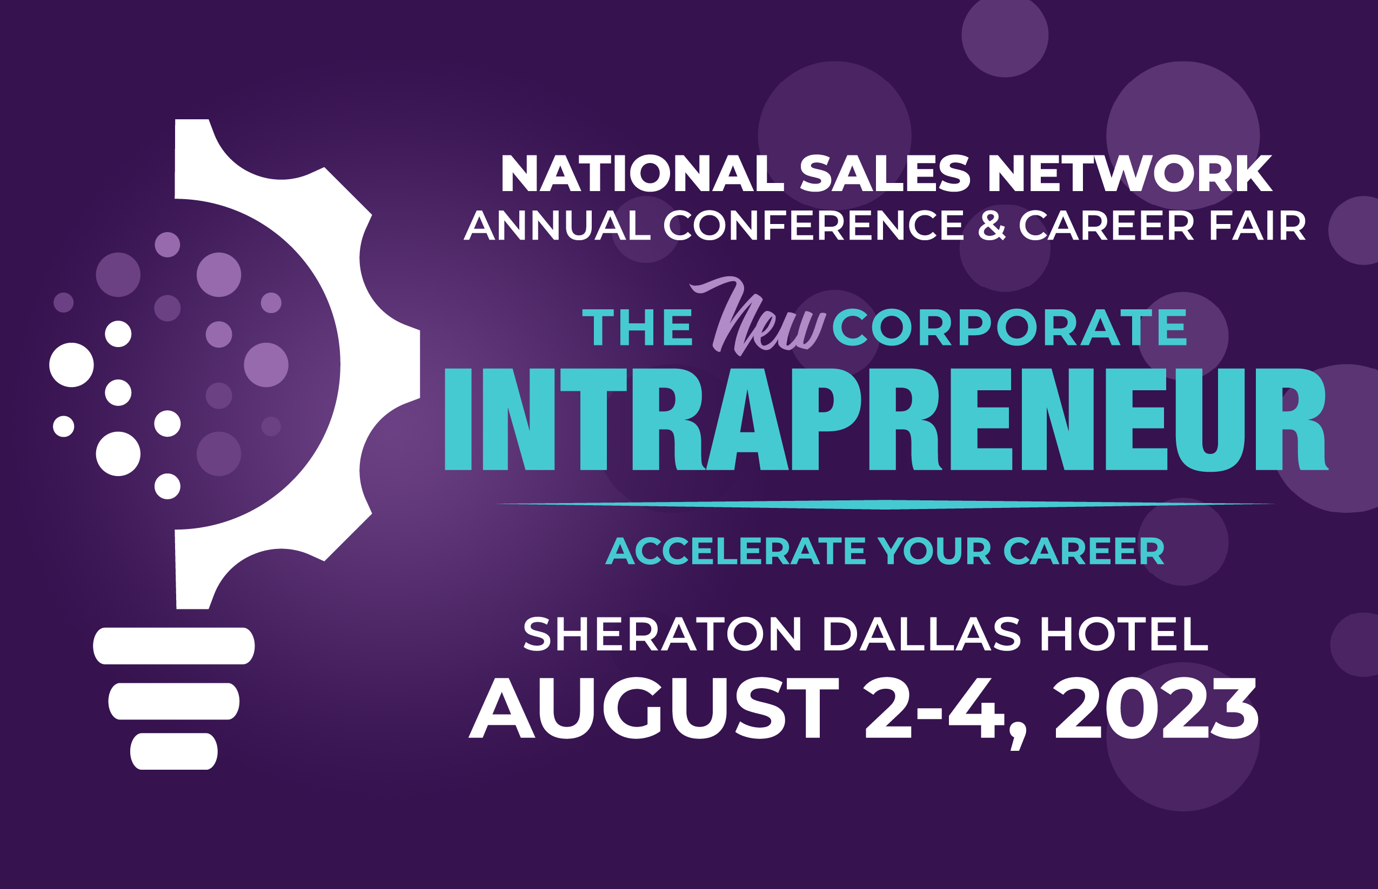
Corporations like ours are increasingly becoming aware of the value that National Sales Network offers to its participants. NSN members and conference attendees are able to discover what it takes to be successful in a changing marketplace and acquire tangible skills that go beyond what is offered by company driven internal sales & sales management training programs. Attendees of the NSN Conference interact with executive-level professionals and are inspired by nationally renowned speakers. They take part in interactive workshops that fine-tune skills, enhance professional development, build working relationships and increase business acumen.
Established in 1992, National Sales Network is a 501(c)(3) non-profit organization whose mission is to meet the professional and developmental needs of diverse sales and sales management professionals. The purpose of the organization is to increase career growth and skill development as well as provide a forum for networking within the sales profession. This is accomplished through the national conference and 17 local NSN chapters and its 1 international chapter in London, UK. Please visit their website at www.salesnetwork.org for additional information.
I am requesting your support to attend the NSN Conference this year as a part of my professional development. For over 30 years, companies across the globe have recognized the NSN Conference as an integral part of the individual development plan for their employees. I hope you will consider sponsoring my participation.
Sincerely,
(Your name)

